Error: ConnectionError: Failed to connect to localhost:1433 - Could not connect (sequence)

at C:\Repos\capstone\jeng\BCI\bci-api\node_modules\mssql\lib\tedious\connection-pool.js:71:17

at Connection.onConnect (C:\Repos\capstone\jeng\BCI\bci-api\node_modules\tedious\lib\connection.js:1043:9)

Make sure SQL TCP/IP is enabled

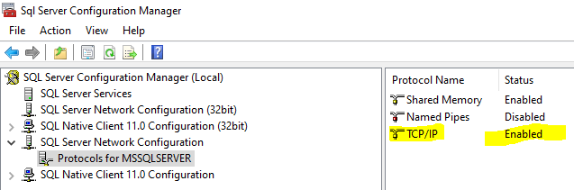

Restart all services

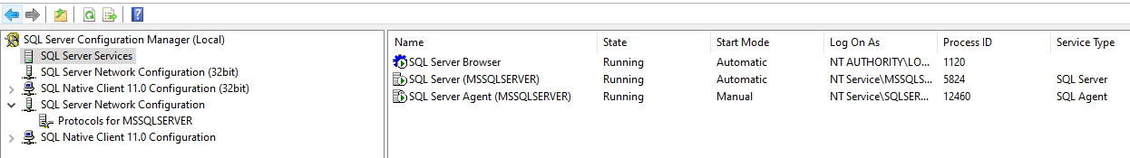

Make sure to enable sql auth

